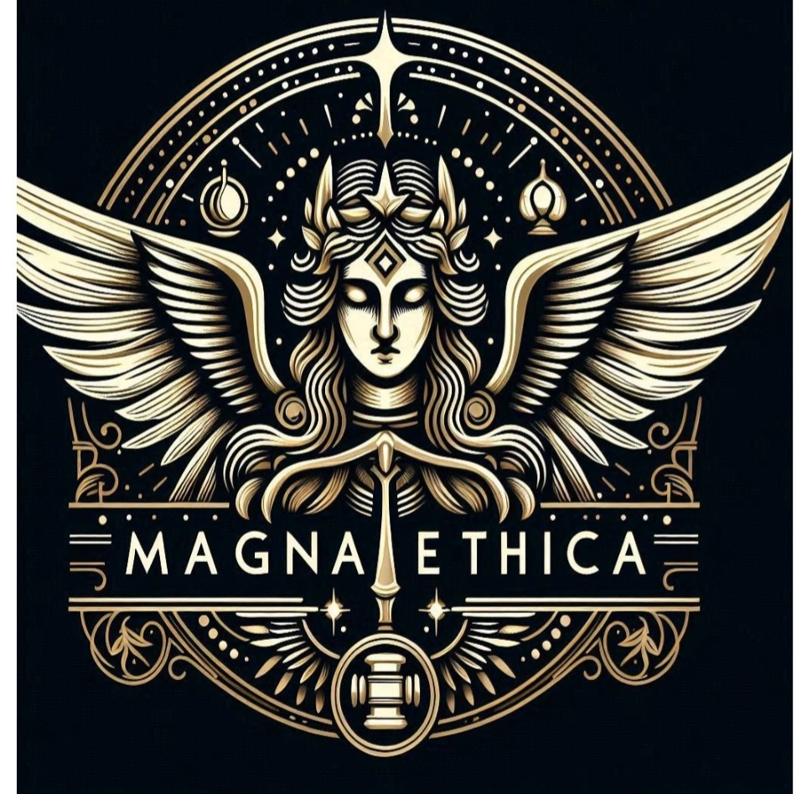

Survey on the Importance of Ethics and Compliance in Your Company

**Purpose:**

**This survey aims to evaluate the role and significance of ethics and compliance within your organization. The results will help identify areas of strength and opportunities for improvement in fostering an ethical and compliant corporate culture.**

**Confidentiality Statement:**

**Your responses will remain confidential and will only be used in aggregate form to improve the ethical standards and compliance measures of the organization.**

**Section 1: General Perception of Ethics and Compliance**

**1. How important do you believe ethics and compliance are to the overall success of the company?**

**- Extremely Important**

**- Very Important**

**- Moderately Important**

**- Slightly Important**

**- Not Important**

**2. To what extent do you agree with the following statement: "Our company prioritizes ethics and compliance in its business operations."**

**- Strongly Agree**

**- Agree**

**- Neutral**

**- Disagree**

**- Strongly Disagree**

**3. How well do you understand the ethical standards and compliance policies of our company?**

**- Very Well**

**- Well**

**- Moderately**

**- Poorly**

**- Not at All**

**4. In your opinion, how effectively does our company communicate its expectations regarding ethics and compliance?**

**- Extremely Effectively**

**- Very Effectively**

**- Somewhat Effectively**

**- Slightly Effectively**

**- Not Effectively**

**Section 2: Organizational Culture and Ethical Climate**

**5. How often do you observe behaviors or practices that you believe are unethical or non-compliant within the company?**

**- Very Often**

**- Often**

**- Sometimes**

**- Rarely**

**- Never**

**6. To what extent do you feel comfortable reporting unethical behavior or non-compliance within the company?**

**- Very Comfortable**

**- Somewhat Comfortable**

**- Neutral**

**- Somewhat Uncomfortable**

**- Very Uncomfortable**

**7. Do you believe that employees who report unethical behavior or non-compliance are protected from retaliation?**

**- Strongly Believe**

**- Believe**

**- Neutral**

**- Disbelieve**

**- Strongly Disbelieve**

**8. How frequently do you receive training or communication about ethics and compliance?**

**- Regularly (At least quarterly)**

**- Occasionally (Bi-annually)**

**- Rarely (Annually)**

**- Never**

**Section 3: Leadership and Management**

**9. How committed do you believe senior leadership is to upholding ethical standards and compliance?**

**- Extremely Committed**

**- Very Committed**

**- Moderately Committed**

**- Slightly Committed**

**- Not Committed**

**10. To what extent do managers and supervisors model ethical behavior and compliance?**

**- Always**

**- Frequently**

**- Sometimes**

**- Rarely**

**- Never**

**11. In your opinion, how effective is the leadership in addressing ethical concerns or compliance issues when they arise?**

**- Extremely Effective**

**- Very Effective**

**- Moderately Effective**

**- Slightly Effective**

**- Not Effective**

**---**

**Section 4: Personal Experience and Feedback**

**12. Have you ever encountered a situation where you felt pressured to compromise ethical standards or compliance in your role?**

**- Yes**

**- No**

**- *If Yes, please provide a brief description (optional):\***

**____________________________________________**

**13. How confident are you that the company’s ethics and compliance programs are sufficient to prevent unethical behavior?**

**- Very Confident**

**- Confident**

**- Neutral**

**- Doubtful**

**- Very Doubtful**

**14. What additional steps, if any, do you believe the company could take to improve its ethical standards and compliance?**

**_________________________________________**

**15. Overall, how satisfied are you with the company’s commitment to ethics and compliance?**

**- Very Satisfied**

**- Satisfied**

**- Neutral**

**- Dissatisfied**

**- Very Dissatisfied**

**Section 5: Demographics (Optional)**

**16. Please indicate your role within the company:**

**- Senior Management**

**- Middle Management**

**- Junior Management**

**- Non-Managerial Staff**

**- Other (Please specify): ____________________**

**17. How long have you been employed by the company?**

**- Less than 1 year**

**- 1-3 years**

**- 4-6 years**

**- 7-10 years**

**- More than 10 years**

**18. Which department do you work in?**

**- Sales**

**- Marketing**

**- Finance**

**- Operations**

**- Human Resources**

**- IT**

**- Legal**

**- Other (Please specify): ____________________**

**Thank you for your participation!**

**Your feedback is invaluable in helping us maintain the highest standards of ethics and compliance within our organization.**